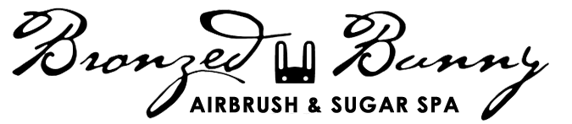

BRONZED BUNNY SUGAR ACADEMY
REGISTRATION FORM

Thank you for your interest in joining the Bronzed Bunny Sugar Academy. To best meet your sugaring needs please complete the brief questionnaire below and return to us via email at info@bronzedbunny.com and we will get back to you with the next steps in the process.

Are you currently certified with another Sugaring Brand? ⎕ No ⎕ Yes
If yes, which one? ___________________________
Are you interested in basic or advanced training? ⎕ Basic ⎕ Advanced
For training what dates and times work best for you? __________________________________
Name: First _________________ Last _______________________
Phone: _____________________
Email: ______________________
Are you currently enrolled in Esthetics or Cosmetology School? ⎕ No ⎕ Yes
If yes, which school? ___________________________
Do you have a minimum of 300 course hours? ⎕ No ⎕ Yes
Please provide your State Esthetician or Cosmetology License Number __________________

If you have any additional questions please contact:
Dominique Cristina Yarumian
Lead Esthetician & Sugarist at The Bronzed Bunny
Cell: 949.344.5094 Work: 949.650.1266
Email: niqui@bronzedbunny.com

